

**Operation Guide: WPC90 (version V5)**

1. **Connections:**
2. **For Single Switch Pump System:** Single switch pump system are those pump system which start and stop pump with a single switch. That means, there is a single switch to turn ON/OFF. See below photo connection for more details

Customer Support  
+91-9125110098

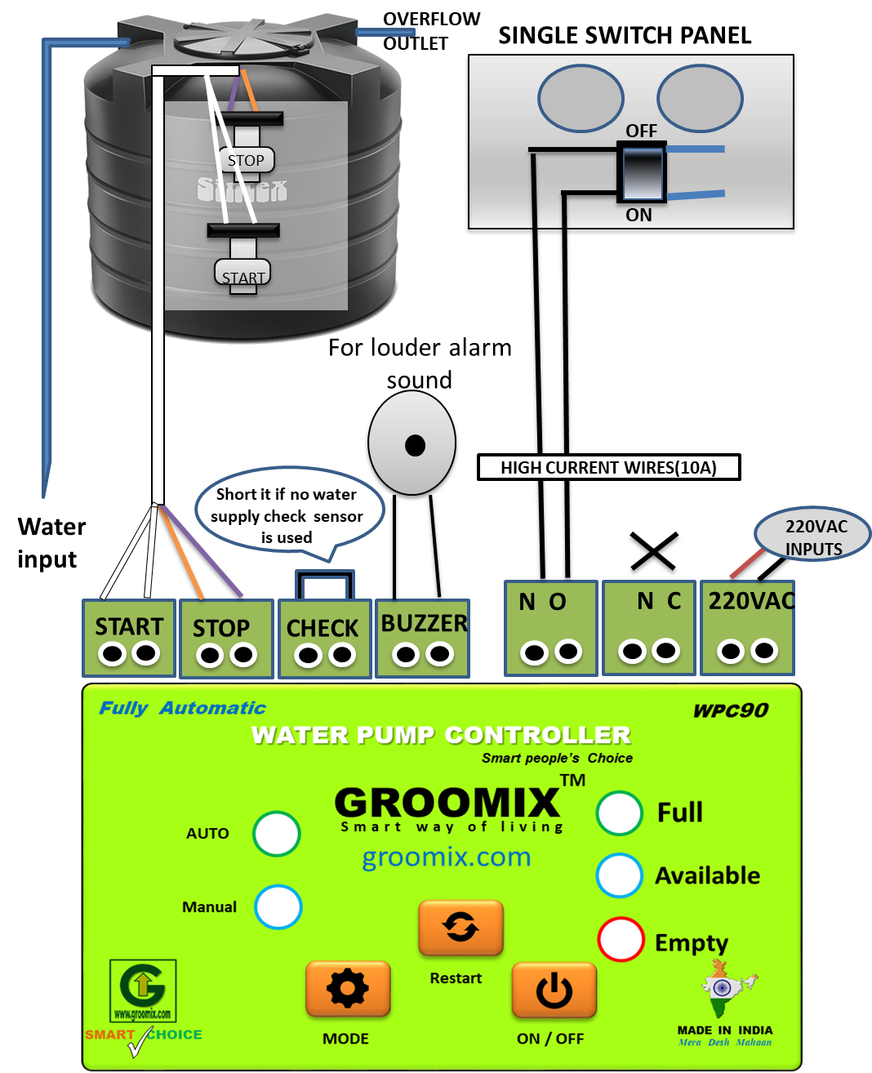

For Auto, keep switch OFF  
For Manual,   
1. Turn OFF controller main switch OFF and use this switch  
2. Change mode of controller and use ON/OFF button

1. **For Two Switch Pump System:** Two switch pump system are those pump system which have start and stop switch seperately. That means, there is an independent switch to turn ON (start button) and turn OFF (stop button). See below photo connection for more details.

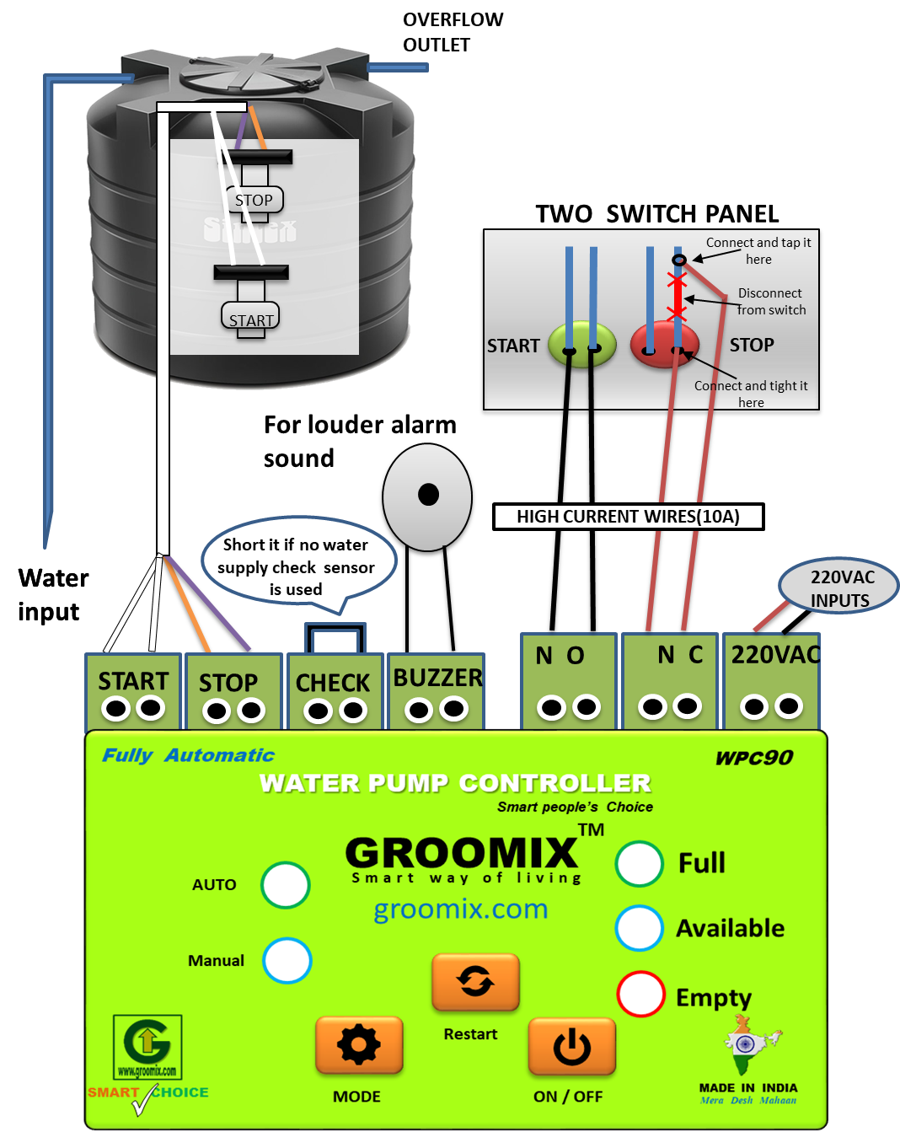

Customer Support  
+91-9125110098

For Manual,   
1. Use this push switches but if you turn ON from here then you need o turn OFF it manually  
2. Change mode of controller and use ON/OFF button

1. **Controller Setting:**
2. **Pump switch type selection**: Check **Pump switch type** by watching on available LED indication just after **Power ON** device, if it blinks one time then it is in **Single switch mode** and if it blinks two time then it is in **Double switch mode**. **Power OFF** device then Press and hold **MODE** button and then **Power ON** device and release **MODE** button just after hearing **10th beep** sound (also available LED will blink). It will change (toggle) pump switch type between single switch mode and double switch mode.
3. **Maximum run time:** To Know “maximum run time” value, turn OFF controller using side “main switch” then after 5 second turn ON it. Then notice the mode indicator LEDs, one LED will grow for 1 sec and that LED value is the maximum run value. (If growing LED is manual, it means its value is 5 hour and if growing LED is auto then is value is unlimited (maximum run time protection is OFF). To change value of “maximum run time” value, turn OFF controller main switch and then keep pressing the mode button and then turn ON controller main switch. Then keep counting “beep sound” or “available LED blink”, after counting **15th beep** release the mode button. Then you are in “maximum run time” setting, just press “mode button” to change the value. And then restart the controller.
4. **Buzzer ON/OFF:** To turn ON or OFF buzzer sound, **Power OFF** device then Press and hold **MODE** button and then **Power ON** device and release **MODE** button just after hearing **20th beep** (or available LED blink count). It will change (toggle) buzzer ON/OFF between ON and OFF mode.
5. **Overflow Alarm enable/disable:** If **“overflow Alarm”** is enabled, controller will beep continuously for 0.5 second (also grow auto and manual LED for 1second) when turn ON controller. To change value of “Overflow Alarm enable/disable”, turn OFF controller main switch and then keep pressing the mode button and then turn ON controller main switch. Then keep counting “beep sound” or “available LED blink”, after counting **25th beep** release the mode button. Then “Overflow Alarm” will change from enable to disable or vice-versa.
6. **Overflow Stop Mode enable/disable:** If **“overflow Stop Mode”** is enabled, controller “auto LED” and “manual LED” will blink alternatively. To change “Overflow Stop Mode enable/disable”, turn OFF controller main switch and then keep pressing the mode button and then turn ON controller main switch. Then keep counting “beep sound” or “available LED blink”, after counting **30th beep** release the mode button. Then “Overflow Stop Mode” will change from enable to disable or vice-versa.
7. **Specifications:**
8. Power supply: 220Vac
9. Sensors: Floating magnet sensor (Normally Open)

Customer Support  
+91-9125110098

1. Sensor wire: Any telephone wire (4 core)
2. Power supply wire: 0.5 mm or above
3. NC or NO connecting wire: 1.0 mm or Above

Customer Support  
+91-9125110098



**USER MANUAL**

Automatic water pump controller

Model: GX-WPC180-V6.3